Account Management – create/edit user accounts
How to add a user to the network called Labnetwork.com

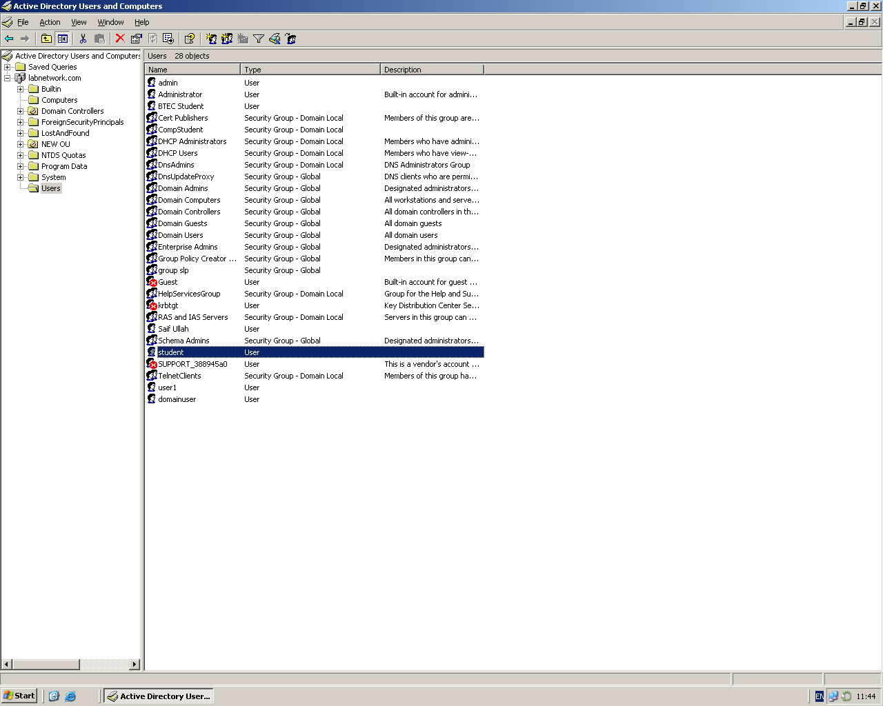

The user: student is already created on the server.
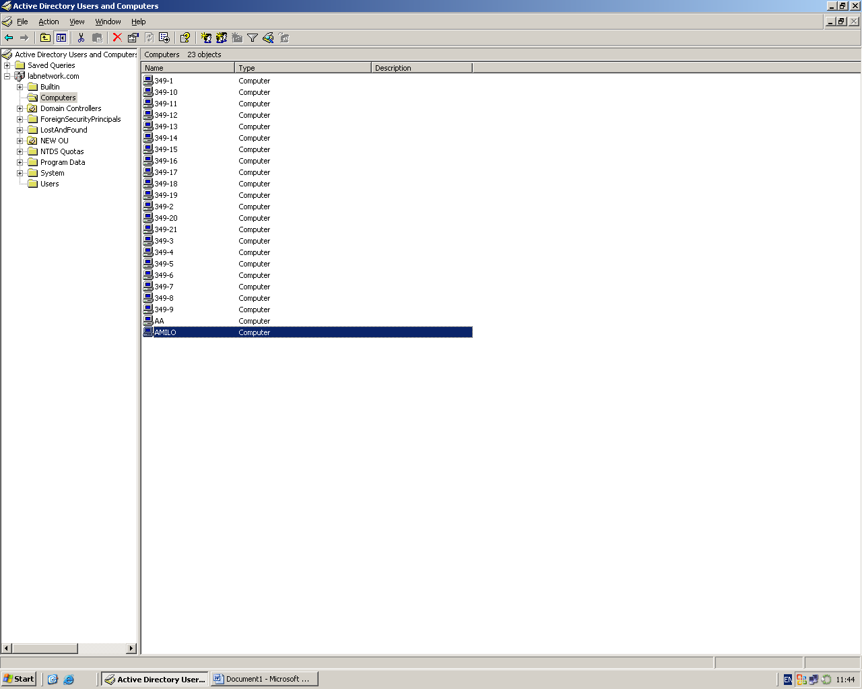

The client computer called: AMILO is part of the network called labnetwork.
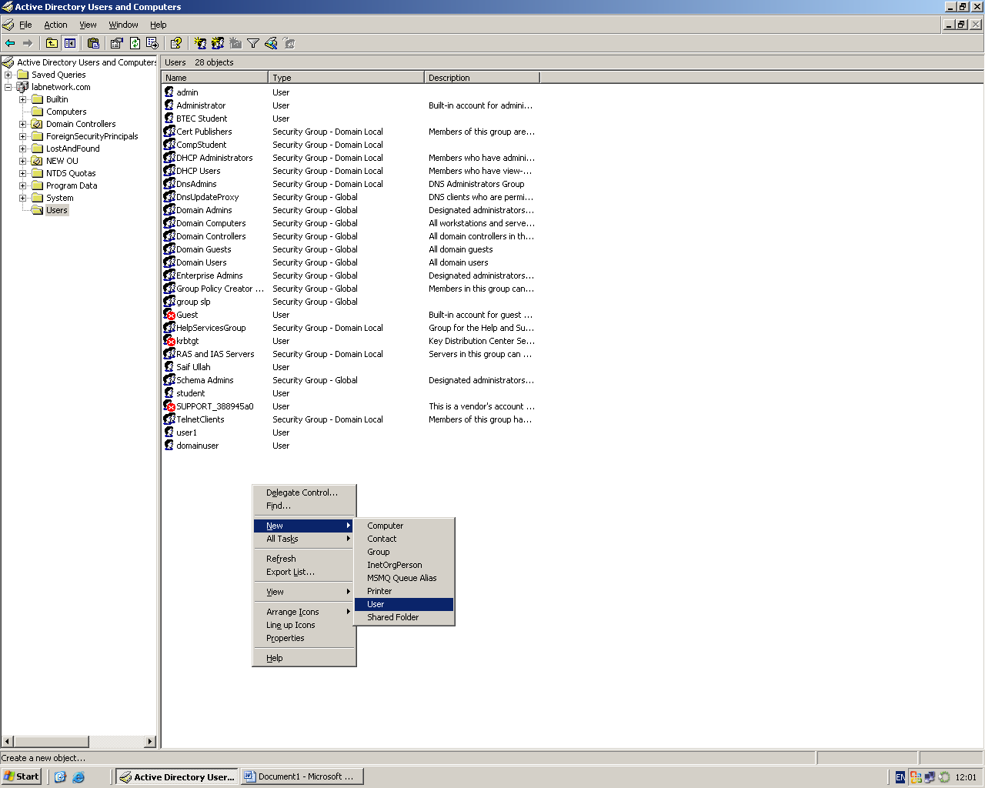

To create a new user
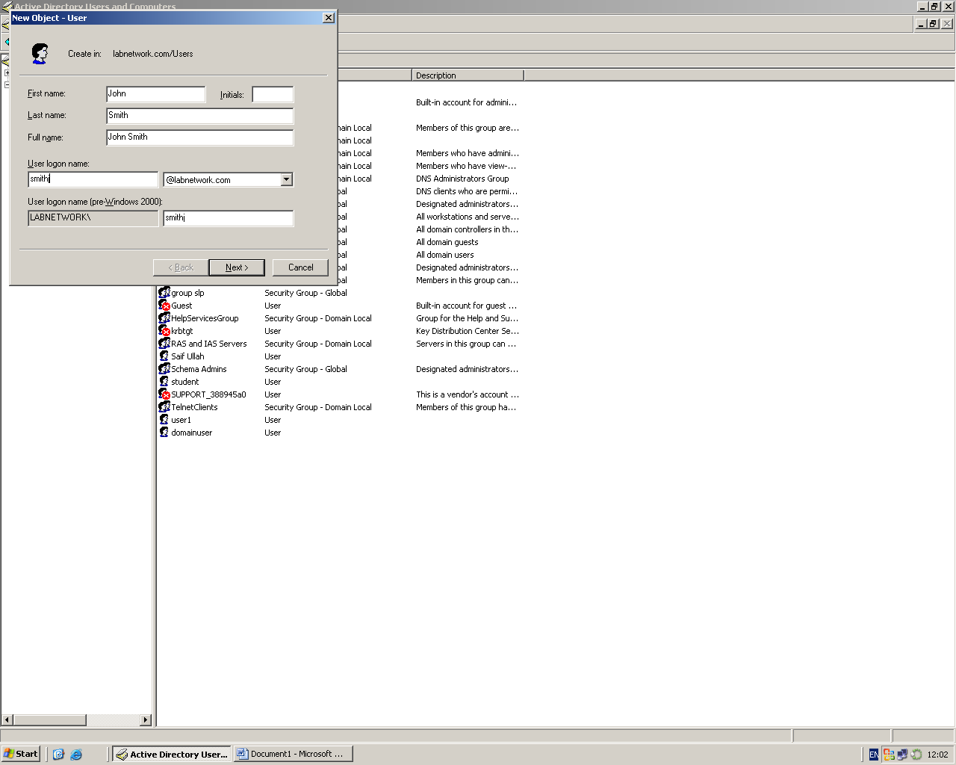

Creating new user called: John Smith with username: smithj
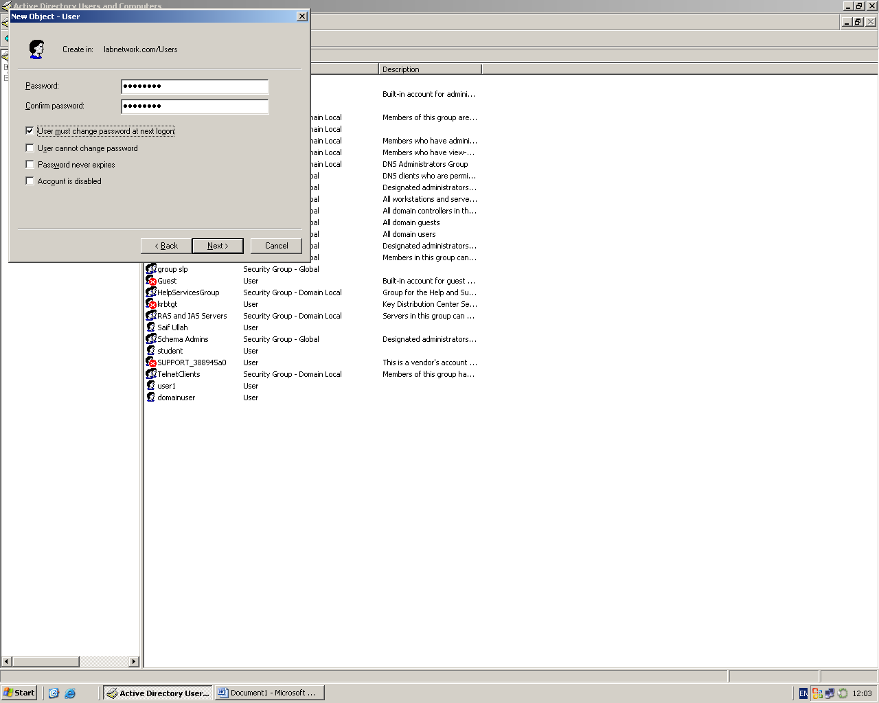

The user will be forced to change password on next logon.
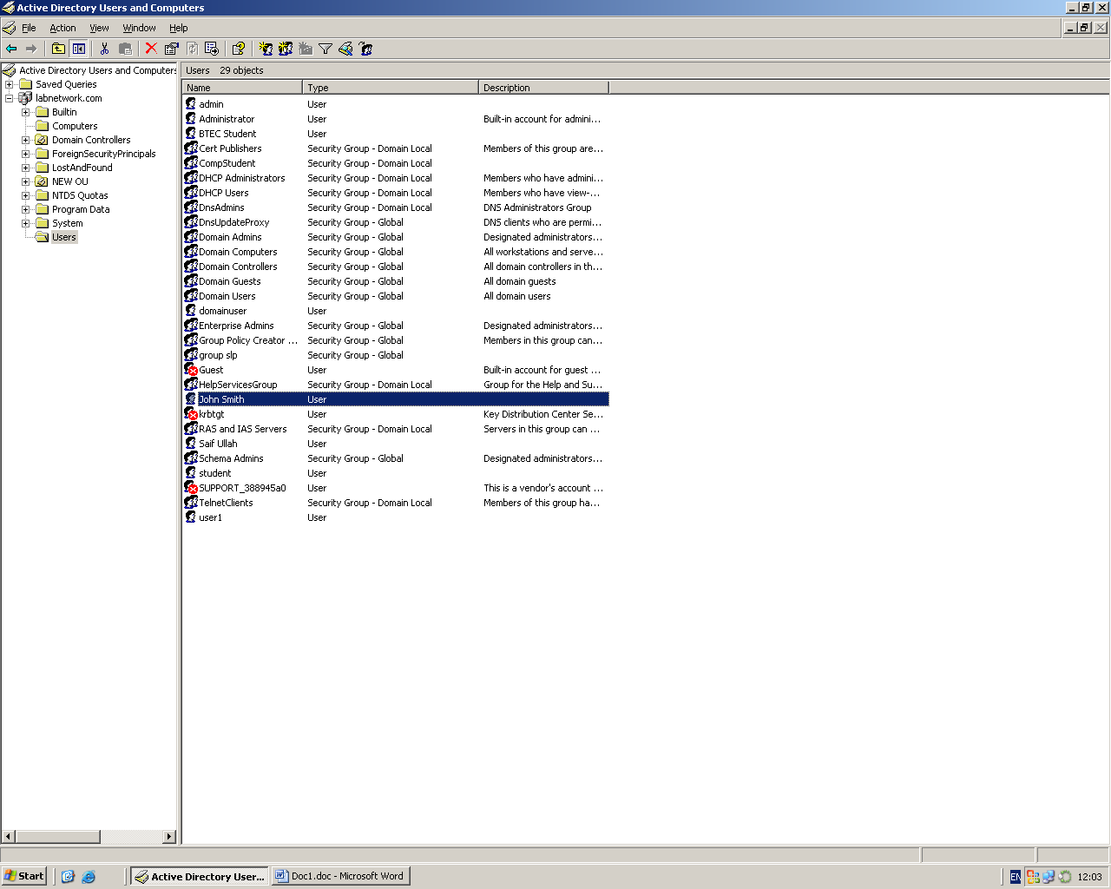
The user: John Smith is created above under users.

